Inputs given to the program :

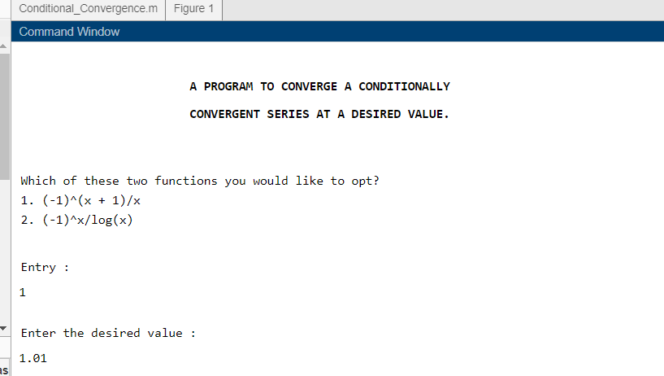

Outputs of the program :

1. First twenty terms(a1,a2,…,a20) of the rearranged series :

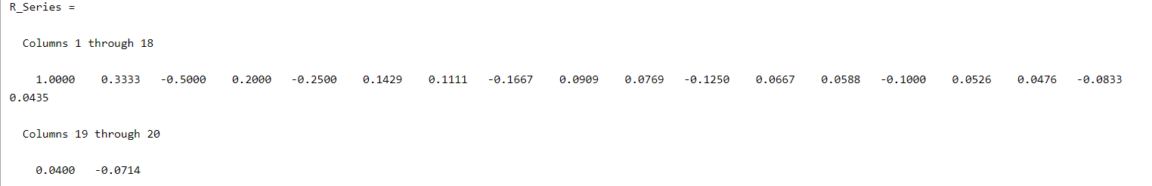

1. First 20 partial sums (S1,S2,…,S20) of the rearranged series :

